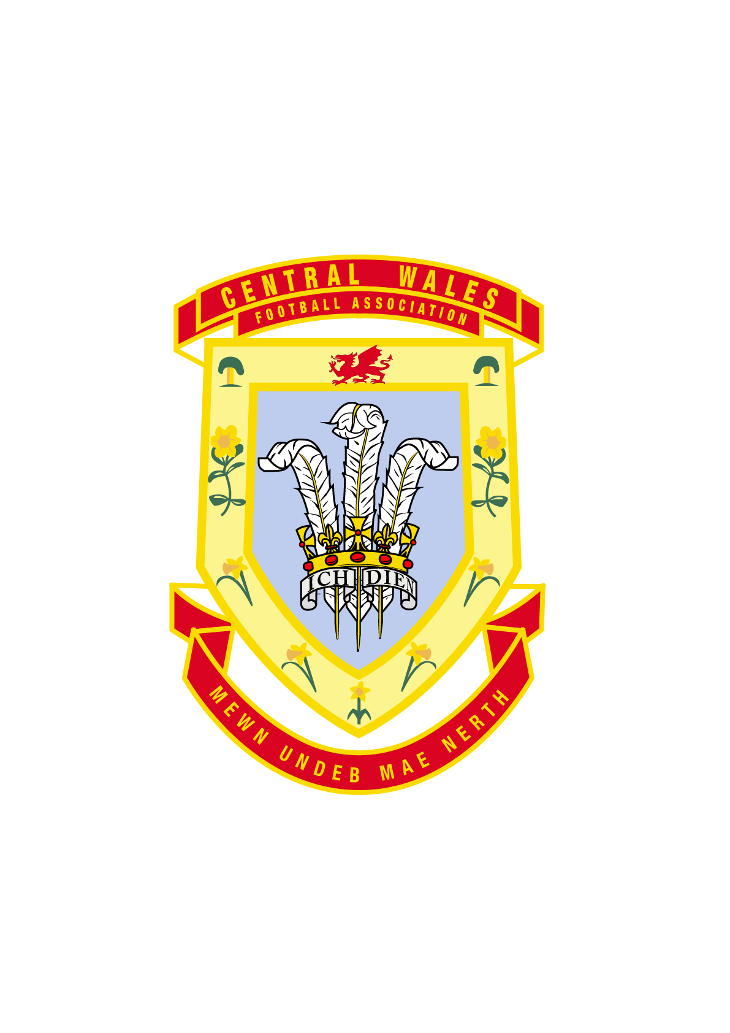
CENTRAL WALES FA
Equality and diversity policy

1 The Association’s commitment
1.1 General commitment
The Central Wales FA (the Association, we or us) is committed to eliminating discrimination and promoting equality and diversity in our own policies, practices and procedures in our work with our members and sub-ordinate’s and in the Association’s dealings with others including the Football Association of Wales and other third parties.
We shall treat everyone equally and with dignity, courtesy and respect regardless of their disability, gender, age, race, racial group, colour, ethnic or national origin, nationality, religion or belief, sexual orientation, trade union status, marriage or civil partnership status, spent conviction or any other personal characteristic.
1.2 Regulation and legislation
In developing and implementing its equality and diversity policy, the Association is committed to complying with all current and any future anti-discrimination legislation and associated codes of practice including, but not limited to:
- Equality Act 2010
- the following codes of practice:
(a) the Commission for Racial Equality code of practice for the elimination of racial discrimination and the promotion of equality of opportunity in employment (1983);
(b) the Equal Opportunities Commission code of practice on sex discrimination; equal opportunities policies, procedures and practices in employment (1985);
(d) the Disability Discrimination Act 1995 codes of practice in relation to rights of access to facilities, services and premises.
and any relevant amendments to or further codes of practice.
2 Forms of discrimination
The Equality Act 2010 defines the various kinds of discrimination with reference to the characteristics which are protected under the Act.
The following are the kinds of discrimination which are prohibited under this policy and the law.
2.1 Direct discrimination (s.13)
Direct discrimination occurs when we treat someone less favourably than another person because:
- they have a protected characteristic;
- they are thought to have a protected characteristic; or
- they associate with someone who has a protected characteristic.
Direct discrimination under the Act is defined as follows:
A person (A) discriminates against another (B) if, because of a protected characteristic, A treats B less favourably than A treats or would treat others.
This definition of direct discrimination applies to all protected characteristics. In relation to the protected characteristic of age, direct discrimination can be justified if it is a proportionate means of achieving a legitimate aim.
Separate provisions exist in respect of discrimination against a woman on the grounds of pregnancy or maternity (ss.17 and 18).
2.2 Indirect discrimination (s.19)
Indirect discrimination occurs when a policy or practice that we adopt particularly disadvantages people who share a protected characteristic. Indirect discrimination under the Act is defined as follows:
A person (A) discriminates against another (B) if A applies to B a provision, criterion or practice which is discriminatory in relation to a relevant protected characteristic of B’s.
Indirect discrimination can only be justified if we can show that the policy or practice is a proportionate means of achieving a legitimate aim.
Indirect discrimination had already applies to age, race, religion or belief, sex, sexual orientation and marriage, civil partnership, disability and gender re-assignment. It does not apply to pregnancy or maternity.
2.3 Harassment
Harassment is defined in the Act as: ‘unwanted conduct related to a relevant protected characteristic’, which has the purpose or effect of violating an individual’s dignity or ‘creating an intimidating, hostile, degrading, humiliating or offensive environment’ for that individual.
Harassment applies to all protected characteristics except for pregnancy and maternity, and marriage and civil partnership.
The Act specifically prohibits three types of harassment:
- harassment related to a ‘relevant protected characteristic’;
- sexual harassment; and
- less favourable treatment because they submit to or reject sexual harassment related to sex or gender reassignment.
2.4 Victimisation (s.27)
Victimisation occurs when we subject a person to a detriment because the person has carried out or is believed to have carried out what is referred to as a ‘protected act’.
A protected act is any of the following (s.27(2)):
- bringing proceedings under the Act;
- giving evidence or information in proceedings brought under the Act;
- doing anything which is related to the provisions of the Act;
- making an allegation that another person has done something in breach of the Act.
3 Promoting equality and diversity
The Association is committed to promoting equality and diversity in the firm as well as in those areas in which it has influence.
In all its dealings, including those with members and sub-ordinates, the FAW and any other third parties, the firm will seek to promote the principles of equality and diversity and will take reasonable steps to ensure appropriate standards in relation to this policy are maintained.
The firm will make every effort to reflect its commitment to equality and diversity in its marketing and communication activities including, but not limited to, accessible print and online formats.
4 Implementing the policy
4.1 Responsibility
Ultimate responsibility for implementing the policy rests with the Association
All Council members are expected to pay due regard to the provisions of the Association’s equality and diversity policy and are responsible for ensuring compliance with it when undertaking their roles.
4.2 Complaints of discrimination
The Association will treat seriously, and will take appropriate action concerning, all complaints of discrimination or harassment on any of the forbidden grounds made by members, sub-ordinates or other third parties
All complaints will be investigated in accordance with the Association’s discipline and grievance and/or complaints procedure and the complainant will be informed of the outcome.

